SEC : A PROGRAMS ON THREADS BATCH : A3

REG: 190905513 LAB 06 NAME: MOHAMMAD DANISH EQBAL

LAB EXERCISES:

1. Write a multithreaded program that generates the Fibonacci series. The program should work as follows: The user will enter on the command line the number of Fibonacci numbers that the program is to generate. The program will then create a separate thread that will generate Fibonacci numbers, placing the sequence in data that is shared by the threads(an array is probably the most convinient data structure). When the thread finishes execution the the parent will output the sequence generated by the child thread. Because the parent thread cannot begin outputting the Fibonacci sequence until the child thread finishes, this will require having the parent thread wait for child thread to finish.

Program:

#include<stdio.h>
#include<stdlib.h>
#include<pthread.h>

void* generate_fibonacci(void* param)
{
int* arr = (int*)param;
int n = arr[0];
arr[1] = 0;
arr[2] = 1;

for(int i = 3;i <= n;i++)
{
arr[i] = arr[i-1] + arr[i-2];
}
return NULL;
}

int main(int argc, char const *argv[])
{
int n;
printf("Enter no of Fibonacci numbers : \n");
scanf("%d",&n);

int* arr = (int*)malloc((n+1)*sizeof(int));
arr[0] = n;

pthread_t thread;
pthread_create(&thread,0,&generate_fibonacci,(void*)arr);
pthread_join(thread,0);

for(int i = 1;i <= n;i++)
printf("%d ",arr[i]);
printf("\n");

return 0;
}

Output:

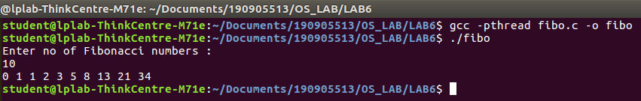

2. Write a multithreaded program that calculates the summation of non-negative integers in a separate thread and passes the result to main thread.

Program:

#include<stdio.h>
#include<stdlib.h>
#include<pthread.h>

void* summation(void* param)
{
int* arr = (int*)param;
int sum = 0;
int n = arr[0];

for(int i = 1;i <= n;i++)
{
if(arr[i] > 0)
sum += arr[i];
}

return (void*)sum;
}

int main(int argc, char const *argv[])
{
int n;

printf("Enter the no. of numbers : \n");
scanf("%d",&n);

int* arr = (int*)malloc((n+1)*sizeof(int));

arr[0] = n;

printf("Enter the numbers : \n");

for(int i= 1;i <= n;i++)
{
scanf("%d",&arr[i]);
}

int answer = 0;
pthread_t thread;
pthread_create(&thread,0,&summation,(void*)arr);
pthread_join(thread,(void**)&answer);

printf("Summation of non-negative numbers = %d\n",answer);

return 0;
}

Output:

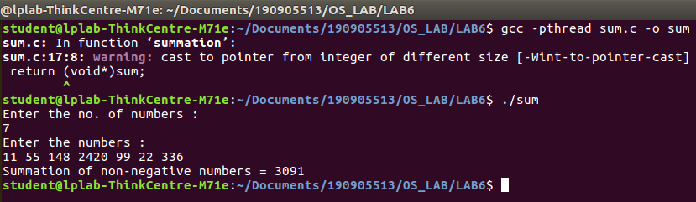

3. Write a multithreaded program for generating prime numbers from a given starting number to the given ending number.

Program:

#include<stdio.h>
#include<pthread.h>

#define N 9999
#define MAX_THREADS 4

int prime_arr[N]={0};

void *printprime(void *ptr)
{
int j,flag;
int i=(int)(long long int)ptr;
while(i<N)
{
flag=0;
for(j=2;j<=i/2;j++)
{
if(i%j==0)
{
flag=1;
break;
}
}

if(flag==0 && (i>1))
{
prime_arr[i]=1;
}
i+=MAX_THREADS;
}
}

int main()
{
pthread_t tid[MAX_THREADS]={{0}};
int count=0;
printf("Enter starting and ending\n");
int st,en;
scanf("%d %d",&st,&en);

for(count=0;count<MAX_THREADS;count++)
{
pthread_create(&tid[count],NULL,printprime,(void*)count);
}
printf("\n");
for(count=0;count<MAX_THREADS;count++)
{
pthread_join(tid[count],NULL);
}

int c=0;

for(count=st;count<en;count++)
if(prime_arr[count]==1)
printf("%d ",count);
printf("\n");

return 0;
}

Output:
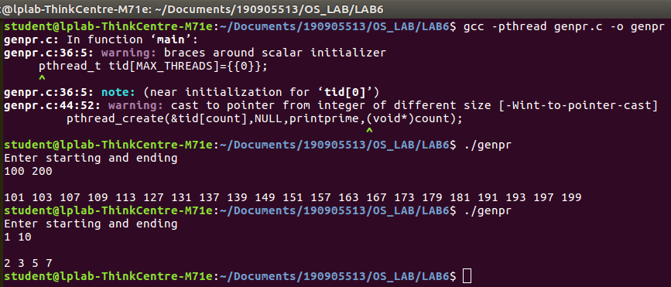

4. Write a multithreaded program that performs the sum of even numbers and odd numbers in an input array. Create a separate thread to perform the sum of even numbers and odd numbers. The parent thread has to wait until both the threads are done.

Program:

#include <stdlib.h>
#include <stdio.h>
#include <pthread.h>
#include <string.h>
void *even(void *brr)
{
int *arr = (int *)brr;
int size = arr[0];
int sum = 0;
for (int i = 1; i <= size; i++)
if (arr[i] % 2 == 0)
sum += arr[i];
return (void *)sum;
}
void *odd(void *brr)
{
int *arr = (int *)brr;
int size = arr[0];
int sum = 0;
for (int i = 1; i <= size; i++)
if (arr[i] % 2 != 0)
sum += arr[i];
return (void *)sum;
}
int main()
{
int n, evenSum, oddSum;
printf("Enter The Number of Elements of the Array: \n");
scanf("%d", &n);
int arr[n + 1];
arr[0] = n;
printf("Enter The Elements in the Array:\n");
for (int i = 1; i <= n; i++)
scanf("%d", &arr[i]);
pthread_t t1, t2;
pthread_create(&t1, 0, &even, (void *)arr);
pthread_create(&t2, 0, &odd, (void *)arr);
pthread_join(t1, (void *)&evenSum);
pthread_join(t2, (void *)&oddSum);
printf("The Sum of Even Numbers of the Array is: %d\n", (int)evenSum);
printf("The Sum of Odd Numbers of the Array is: %d\n", (int)oddSum);
}

Output:

